SCHOOL OF COMPUTER SCIENCE AND ARTIFICIAL INTELLIGENCE |  |  |  |  | DEPARTMENT OF COMPUTER SCIENCE ENGINEERING
Program Name: B. Tech |  |  |  | Assignment Type: Lab |  |  | Academic Year:2025-2026
Course Coordinator Name |  |  |  | Venkataramana Veeramsetty
Instructor(s) Name |  |  |  | Dr. V. Venkataramana (Co-ordinator)  Dr. T. Sampath Kumar  Dr. Pramoda Patro  Dr. Brij Kishor Tiwari  Dr.J.Ravichander  Dr. Mohammand Ali Shaik  Dr. Anirodh Kumar  Mr. S.Naresh Kumar  Dr. RAJESH VELPULA  Mr. Kundhan Kumar  Ms. Ch.Rajitha  Mr. M Prakash  Mr. B.Raju  Intern 1 (Dharma teja)  Intern 2 (Sai Prasad)  Intern 3 (Sowmya)  NS_2 ( Mounika)
Course Code |  |  | 24CS002PC215 | Course Title |  | AI Assisted Coding
Year/Sem |  |  | II/I | Regulation |  | R24
Date and Day  of Assignment |  |  | Week 11 - Friday | Time(s)
Duration |  |  | 2 Hours | Applicable to  Batches
AssignmentNumber:21.5(Present assignment number)/24(Total number of assignments)
 | Q.No. | Question |  |  |  |  |  | Expected Time  to complete
 | 1 | Lab 21: Collaborative AI Coding: Pair programming and version control integration  Lab Objective  The objective of this lab is to enable students to practice collaborative software development workflows by combining AI-assisted coding, pair programming techniques, and version control tools. Students will:  - Learn to use AI coding assistants as a “third partner” in pair programming, generating and refining code collaboratively.  - Understand and apply Git-based version control workflows (branching, merging, conflict resolution) in multi-developer environments.  - Practice reviewing AI-generated code critically before committing it to shared repositories.  - Gain hands-on experience in team collaboration, ensuring accountability, reproducibility, and efficiency in AI-supported coding projects.  Scenario-Based Lab Questions  Lab Question 1: Team-Based Feature Implementation  Your team is building a simple To-Do List application. You are paired with another student, and AI assistance is available for generating boilerplate code.  - Task 1: Use AI assistance to generate a function that adds new tasks to the list. Commit your code to a shared GitHub repository on a new branch named feature-ad-task.  - Task 2: Perform a peer code review of your partner’s branch and merge their code into the main branch, resolving any conflicts. Document on how AI-generated code was improved during the review.  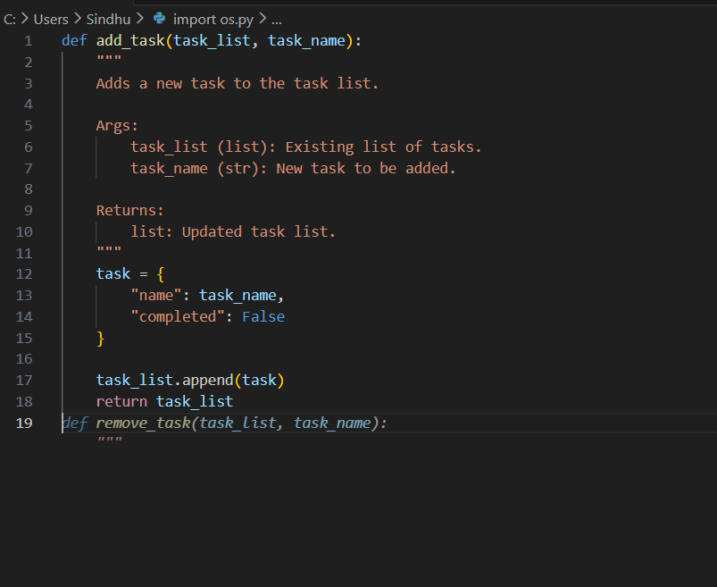  Lab Question 2: Debugging with AI and Pair Programming  An AI-generated script for calculating student grades has errors in its logic (e.g., wrong calculation of averages).  - Task 1: Pair with another student to identify the errors and use AI assistance to suggest debugging strategies. Push the corrected version to a branch called bugfix-grades.  - Task 2: Use Git to create a pull request, assign it to your partner for review, and integrate feedback before merging into the main branch. Record the final changes after the review.  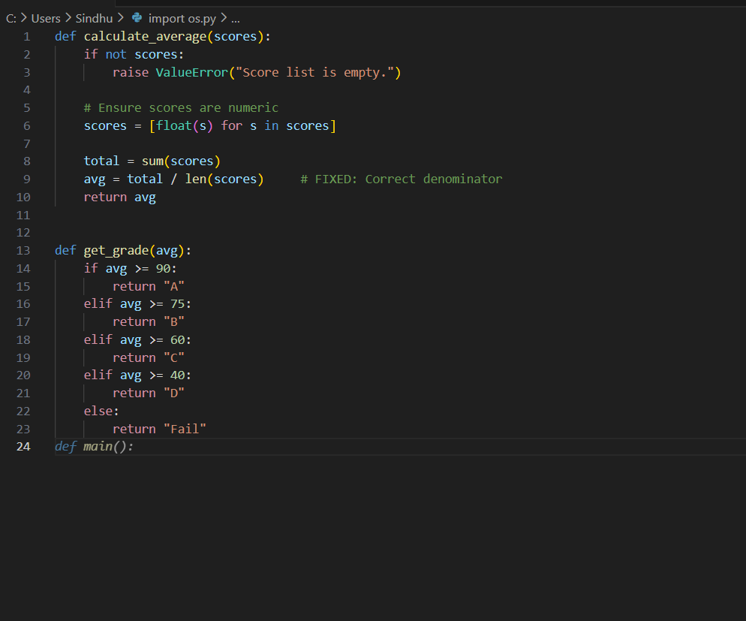  Lab Question 3: Collaborative Documentation and Testing  Your team is developing a currency converter tool. The core code is already written but lacks documentation and test cases.  - Task 1: Use AI-assisted coding to generate docstrings and comments for the existing functions. Commit the changes under the branch docs-update.  - Task 2: Collaboratively generate unit tests with your partner (with AI assistance), run them, and push the tests to a separate branch tests-suite. Merge both documentation and test branches into the main project, resolving merge conflicts if they occur.  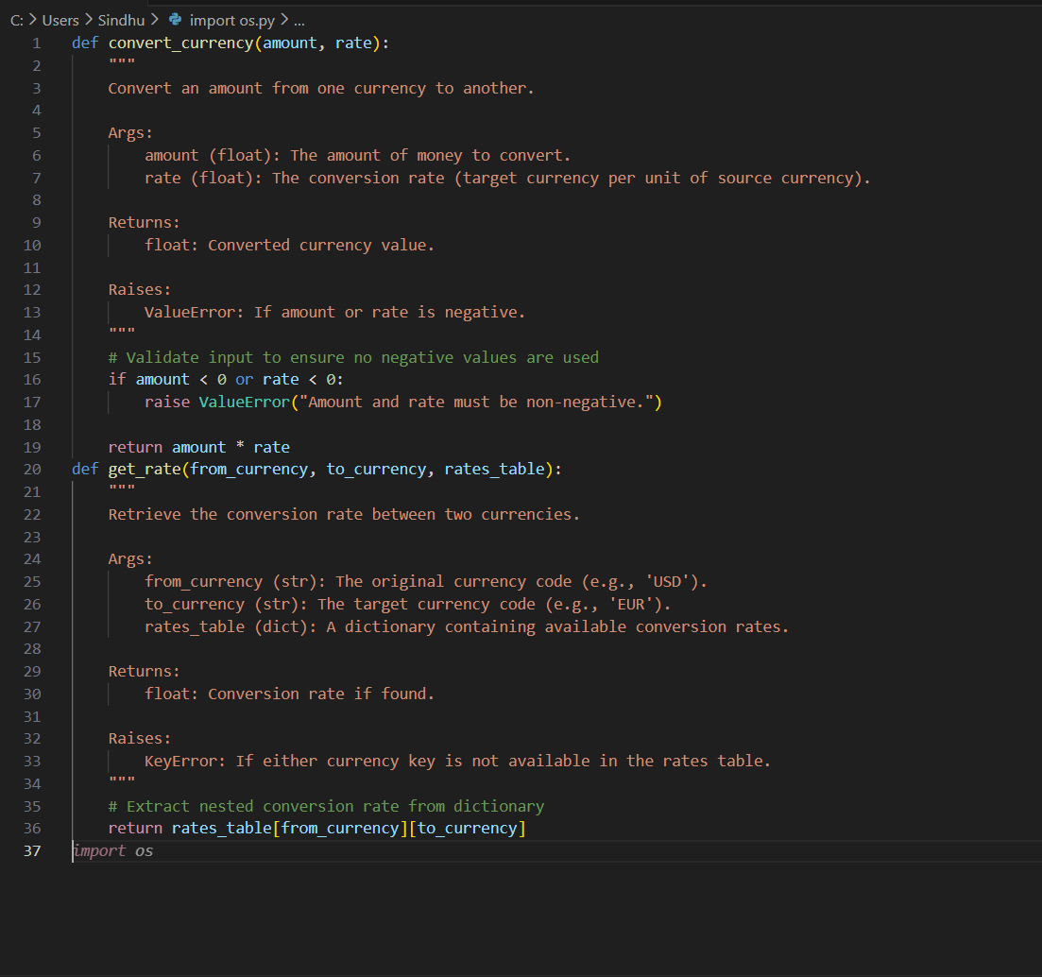 |  |  |  |  |  | Week 11 - Friday

